Separating Mixtures Lab
CSCOPE Unit 02 Lesson 02 Day 3

Vocabulary

Chromatography |  | a set of laboratory techniques that separates one component in a mixture from a similar component in that same mixture, can be used to separate compounds that are chemically very similar
Component |  | one part that makes up something more complex
Decantation |  | to pour a liquid from one container into another without disturbing any solids in the first container
Distillation |  | a purification process in which a liquid is evaporated and then condensed again to a liquid, used to separate dissolved solids from liquids, or liquids from liquids, according to boiling point
Evaporation |  | a change from the liquid state to the gaseous state
Filtration |  | separates a solid from a liquid
Sieve |  | an instrument with a circular frame and a mesh bottom through which a mixture is poured; used for separating coarse from fine parts of loose matter

You are going into the lab area to examine setups for equipment and techniques used to separate mixtures.

You will rotate through each of the setups and make notes complete with drawings.

Using Sieves |  | Using Magnets
Notes: |  | Notes:

Using Decantation |  | Using Chromatography
Notes: |  | Notes:

Using Filtration |  | Using Distillation
Notes: |  | Notes:
 |  | 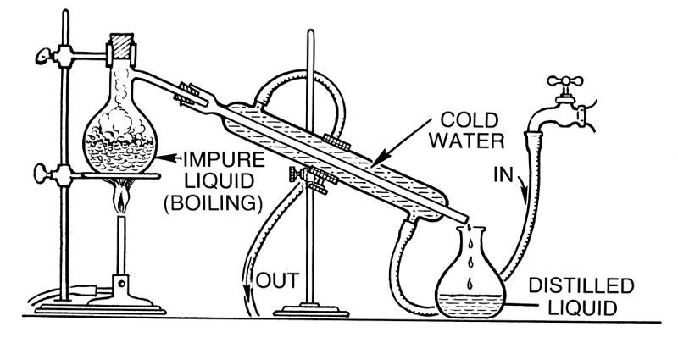

01. Which of these techniques would be the best to use to separate Italian dressing?
02. Which of these techniques would be the best to use to separate water with glitter?
03. Which of these techniques would be the best to use to separate salt water?
04. Which of these techniques would be the best to use to separate oil and water?
05. Other than ones which have already been mentioned, name some mixtures for which the use of magnets would be an appropriate way to separate them:
06. Other than ones which have already been mentioned, name some mixtures for which the use of sieves would be an appropriate way to separate them:
07. Other than ones which have already been mentioned, name some mixtures for which the use of distillation would be an appropriate way to separate them:
08. Other than ones which have already been mentioned, name some mixtures for which the use of filtration would be an appropriate way to separate them:
09. Other than ones which have already been mentioned, name some mixtures for which the use of evaporation would be an appropriate way to separate them:
10. Other than ones which have already been mentioned, name some mixtures for which the use of chromatography would be an appropriate way to separate them:

