Name: ______________________________
Subject & Period: _____________________
Date Due: ___________________________

Label a Blank Periodic Table
CSCOPE Unit 03 Lesson 02 Day 5

Vocabulary

Group |  | a vertical column of elements in the periodic table; also called a family
Period |  | a horizontal row of elements in the periodic table
Metal |  | one of a class of elements that includes a large majority of the known elements; metals are characteristically lustrous, malleable, ductile, and good conductors of heat and electricity
Metalloids |  | one of a class of elements having properties of both metals and nonmetals
Nonmetal |  | one of a class of elements that are not lustrous and are generally poor conductors of heat and electricity; nonmetals are grouped on the right side of the periodic table
Alkali metals |  | any metal in Group I A of the periodic table
Alkaline earth metals |  | any metal in Group II A of the periodic table
Halogens |  | any member of the nonmetallic elements in Group VII A in the periodic table
Noble gases |  | any member of a group of gaseous elements in Group VIII A in the periodic table
Transition metals |  | any element found in the B groups in the periodic table
Atomic radius |  | a way to describe the size of an atom, it is one-half the distance between the nuclei in a molecule consisting of identical atoms
Ionization energy |  | the energy required to remove the outermost electron from a gaseous atom
Metallic character |  | the extent to which an element exhibits the physical and chemical properties characteristic of metals, high metallic character is associated with low ionization energy
Electron affinity |  | the energy change that accompanies the addition of an electron to a gaseous atom
Electronegativity |  | the tendency for an atom to attract electrons to itself when it is chemically combined with another element

In the first part of today’s CSCOPE you will be labeling a blank periodic table to represent key information.

In the second part of today’s CSCOPE you will need to provide a summary of the historical development of the periodic table.

First Part:
Represent the following information on the blank periodic table on the next page:
metals
nonmetals
metalloids
groups
alkali metals
alkaline earth metals
halogens
noble gases
also…
transition metals
periods
“1” through “7”
trends:
electronegativity
ionization energy
metallic character
atomic radius
electron affinity

Second Part:
In the space provided below the periodic table, write a summary of the historical development of the periodic table. Include dates, names, and their key contribution/s.

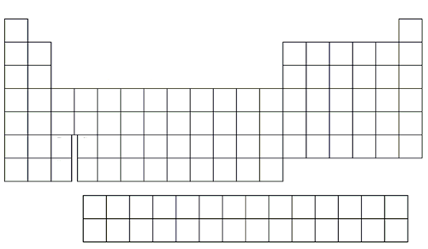

Summary Of The Historical Development Of The Periodic Table

