Shapes of Molecules
CSCOPE Unit 04 Lesson 01 Day 12

Vocabulary

Bonding pair  (shared pair) |  | a pair of electrons shared between two atoms forming a covalent bond, they are represented by a dash between the atoms that are bonded
Central atom |  | an atom in a molecule or polyatomic ion that is bonded to more than one other atom
End atom |  | an atom in a molecule or polyatomic ion that is bonded to the central atom
Lewis electron dot structure |  | a diagram that shows the valence electrons as dots, while the inner electrons and the atomic nucleus are included in the letter symbol for the element being represented
Lone pair (unshared pair) |  | a pair of electrons not used in bonding and not shared with another atom, they are represented by a pair of dots
Valence electrons |  | the electrons involved in chemical bonding, they determine the chemistry of the atom, are the electrons in the highest occupied energy level of an element’s atoms, the “s” and “p” electrons in the highest principal energy level (“n”)
VSEPR Theory |  | a model used to predict the shape of a molecule, based on the assumption that because electron pairs repel, molecules adjust their shapes so that valence electron pairs are as far apart as possible

Model 2: Molecular Geometry

Molecular Geometry
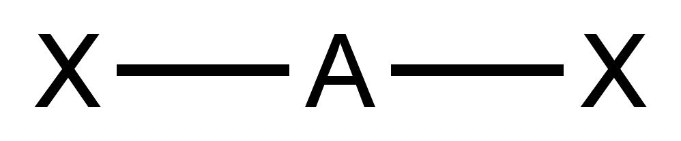 | 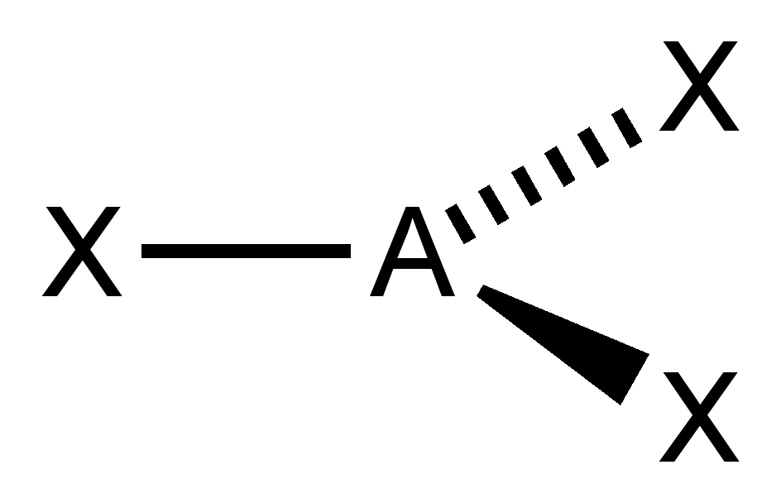 | 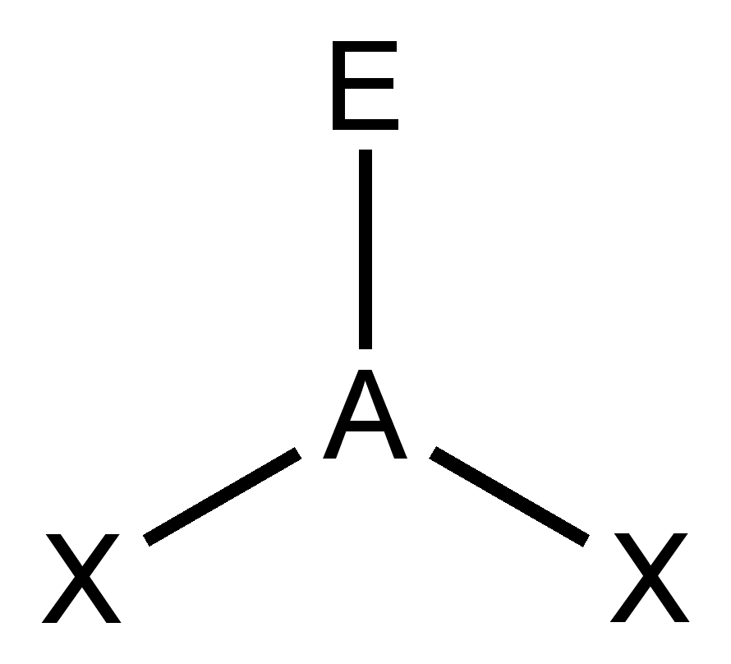 | 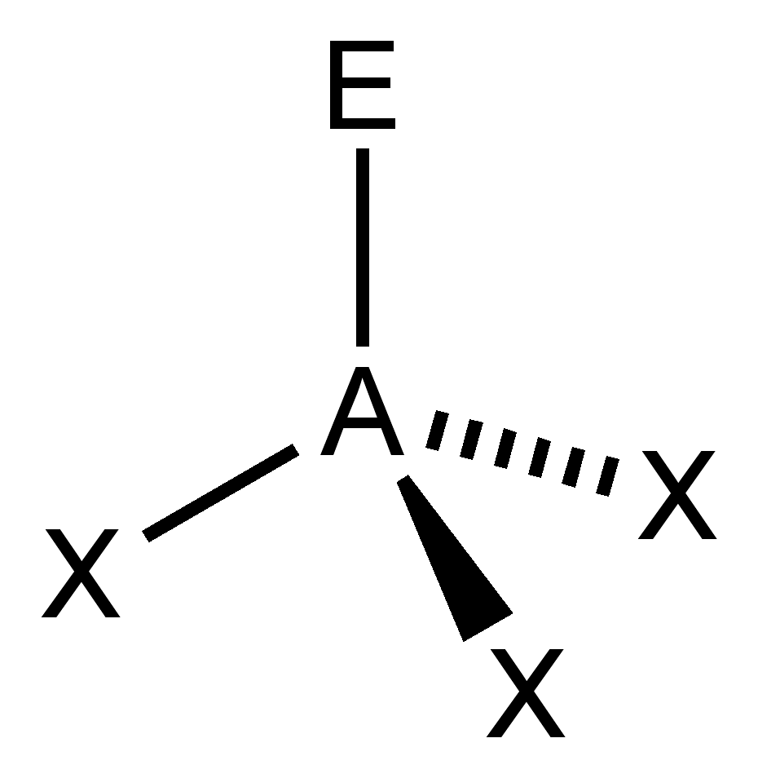 | 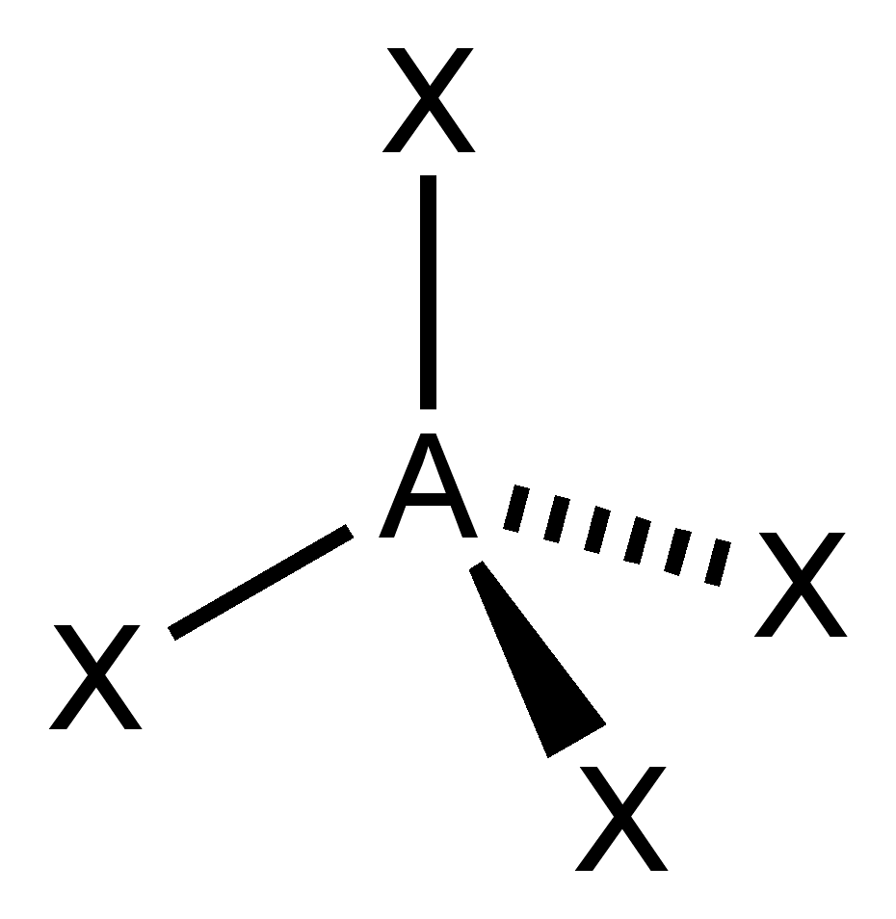
 |  | or
 |  | 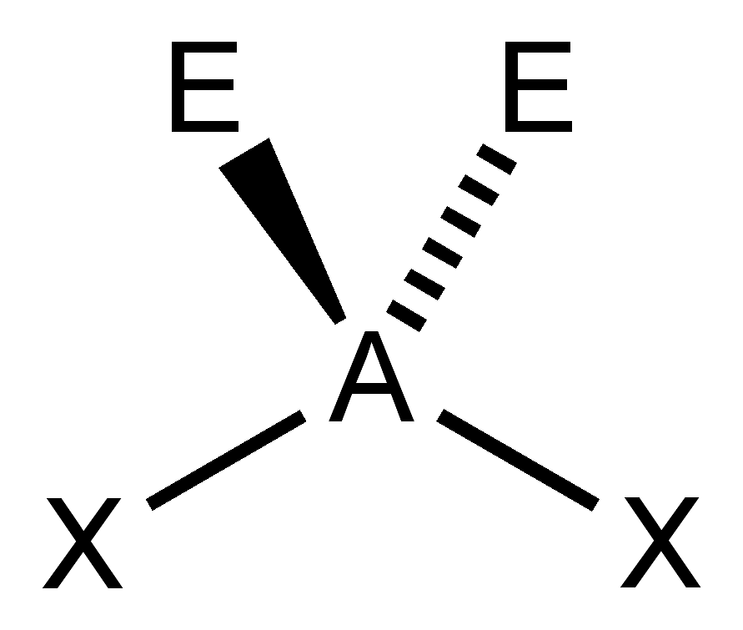
Linear | Trigonal Planar | Bent | Trigonal Pyramidal | Tetrahedral
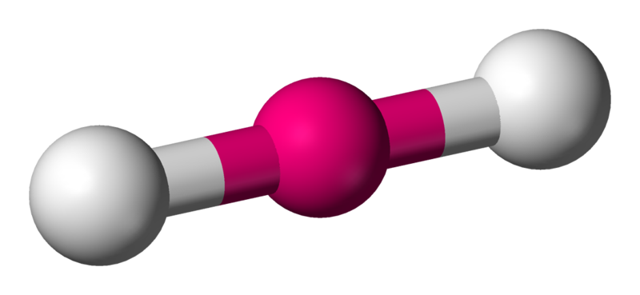 | 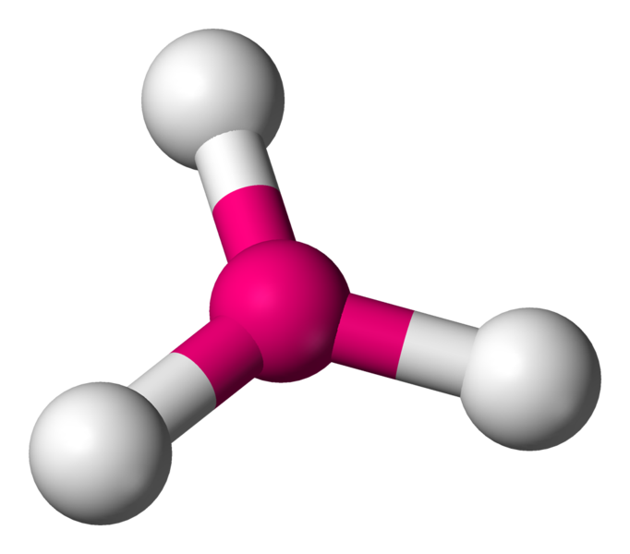 | 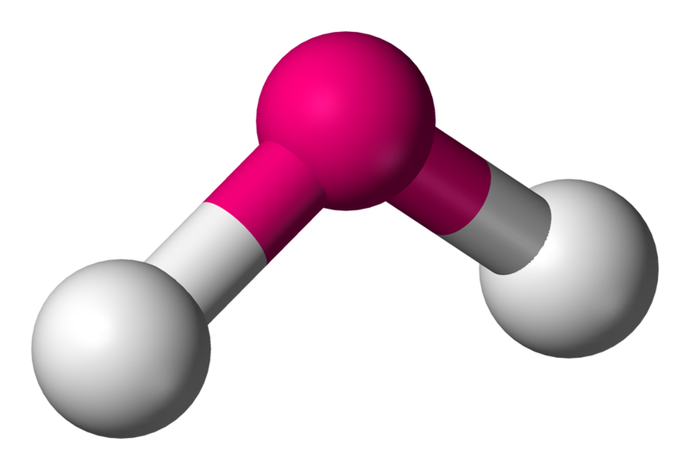 | 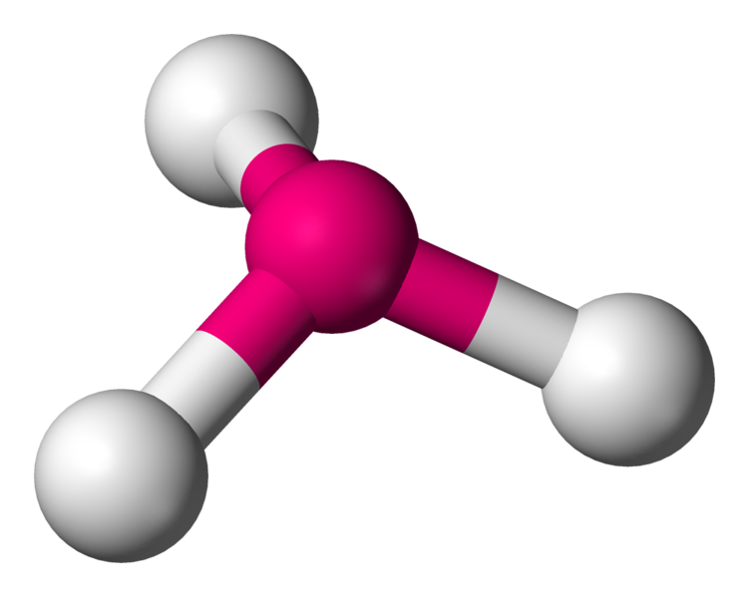 | 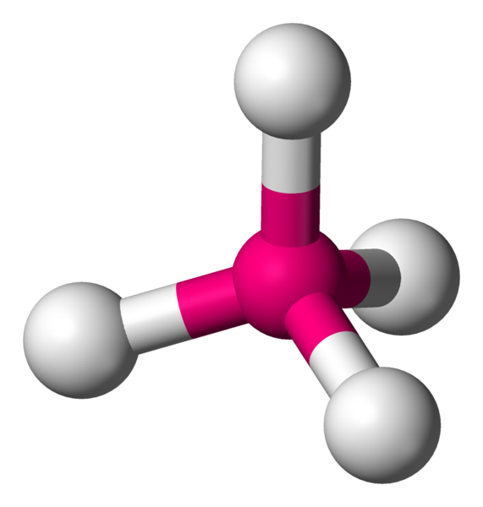

Building Each Of The Five Molecular Geometries

Place two of the toothpicks into a miniature marshmallow, making the angle between each of them as large as possible. Compare this with the diagram of the “Linear” molecular geometry.

Place three of the toothpicks into a miniature marshmallow, making the angle between each of them as large as possible. Compare this with the diagram of the “Trigonal Planar” molecular geometry.

Place four of the toothpicks into a miniature marshmallow, making the angle between each of them as large as possible. Compare this with the diagram of the “Tetrahedral” molecular geometry.

Remove ONE of the four toothpicks from the previous step. Compare this with the diagram of the “Trigonal Pyramidal” molecular geometry.

Remove ONE of the three toothpicks from the previous step. Compare this with the diagram of the “Bent” molecular geometry.

Table of Molecular Geometries

Bonded Atoms | Lone Pairs | Molecular Geometry | Bond Angle | Examples
2 | 0 | linear | 180° | BeF₂
2 | 2 | bent (angular) | less than 109.5° | H₂O
3 | 0 | trigonal planar | 120° | BF₃
3 | 1 | trigonal pyramidal | less than 109.5° | NH₃
4 | 0 | tetrahedral | 109.5° | CH₄

Note: beryllium (Be)…element 4, and boron (B)…element 5 “violate” the octet rule. They can only do this because they have so few electrons to begin with. Once we get to carbon…element 6 the rest of the atoms pretty well have to obey the octet rule.

Examples:

01. Draw the Lewis electron dot structure for
_
CO₂
02. How many atoms are bonded to the central atom?
03. How many lone pairs are on the central atom?
04. Use the Table of Molecular Geometries to predict its shape. What term describes its shape?

Build it using miniature marshmallows for atoms and toothpicks for pairs of electrons on the central atom.

05. Draw the Lewis electron dot structure for
_
H₂CO
06. How many atoms are bonded to the central atom?
07. How many lone pairs are on the central atom?
08. Use the Table of Molecular Geometries to predict its shape. What term describes its shape?

Build it using miniature marshmallows for atoms and toothpicks for pairs of electrons on the central atom.

09. Draw the Lewis electron dot structure for
_
CF₂Cl₂
10. How many atoms are bonded to the central atom?
11. How many lone pairs are on the central atom?
12. Use the Table of Molecular Geometries to predict its shape. What term describes its shape?

Build it using miniature marshmallows for atoms and toothpicks for pairs of electrons on the central atom.

13. Draw the Lewis electron dot structure for
_
NH₃
14. How many atoms are bonded to the central atom?
15. How many lone pairs are on the central atom?
16. Use the Table of Molecular Geometries to predict its shape. What term describes its shape?

Build it using miniature marshmallows for atoms and toothpicks for pairs of electrons on the central atom.

17. Draw the Lewis electron dot structure for
_
H₂S
18. How many atoms are bonded to the central atom?
19. How many lone pairs are on the central atom?
20. Use the Table of Molecular Geometries to predict its shape. What term describes its shape?

Build it using miniature marshmallows for atoms and toothpicks for pairs of electrons on the central atom.

Exercises
For each of the following, draw its Lewis electron dot structure, and then use the
Table of Molecular Geometries to predict its shape.
_
1. COCl₂

_
2. PCl₃

_
3. SiH₄

_
4. SF₂

_
5. SiO₂

_
6. SO₂

_
7. CCl₄

_
8. NF₃

_
9. CS₂

_
10. SO₃

