Metallic Bonding
CSCOPE Unit 04 Lesson 01 Day 13

Vocabulary

Alloy |  | a mixture of two or more metals, or of metallic elements with nonmetallic elements; alloys often have physical properties that are very different from those of the pure metals
Ductile |  | capable of being drawn into a thin shape such as a wire
Delocalized electrons |  | electrons in a solid metal that are not associated with a single atom; they are contained within an orbital that extends over several adjacent atoms
Electrical conductivity |  | the ability of a material to conduct electricity
Lattice |  | a repeating, three-dimensional pattern of points, in this case, metal atoms
Luster |  | a description of the way light interacts with the surface of a metal; the unoxidized surface of a metal is shiny (lustrous) and reflects light
Malleable |  | capable of being shaped by beating with a hammer or by rolling into thin sheets
Metal |  | one of a class of elements that includes a large majority of the known elements; metals are characteristically lustrous, malleable, ductile, and good conductors of heat and electricity
Metallic bonding |  | bonding in which mobile electrons are shared over many nuclei; a metal is held together by the strong forces of attraction between the positive nuclei&inner electrons, and the delocalized electrons.
Metallic character |  | a set of properties that are associated with the elements classified as metals in the periodic table; metallic character depends on the ability of an element to lose its outer valence electrons, i.e. low ionization energy and low electronegativity
Sea of electrons |  | the valance electrons that surround the metallic cations in a metal, these electrons are free, delocalized, mobile, and not associated with any one particular atom; the electrons in the “sea of electrons” can move freely from one atom of metal can move freely to another atom
Tensile strength |  | measures the force required to pull something, such as a wire, to the point where it breaks
Thermal conductivity |  | the ability of a material to conduct heat

Your teacher may perform one or more demonstrations of the properties of metals.
Write your notes about what you are seeing in the space below:

I. The “Sea of Electrons” Model of Metals
In metals, the valence electrons are released from the atom, leaving behind the nucleus and the inner electrons in the form of a metal cation. These valence electrons form a “sea” of free electrons among a lattice of positively charged metal ions. These electrons are delocalized – they are not tied to one atom and are shared among several atoms. Therefore metallic bonding is often described as the metal ions swimming in a “sea of electrons.”

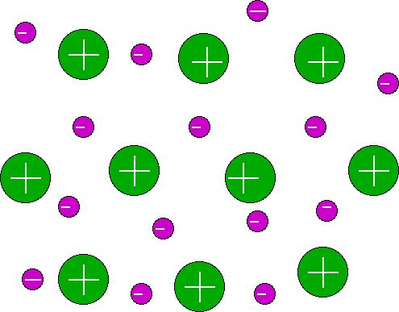
Metallic cations, shown with positive signs, are surrounded by a "sea" of electrons, shown with negative signs.

accessed at: http://chemwiki.ucdavis.edu/
Theoretical_Chemistry/Chemical_Bonding/Metalic_Bonding

II. An explanation of the properties of metals.
A. High electrical conductivity
The “sea of electrons” can flow, easily carrying current through the metal.

B. High thermal conductivity
The “sea of electrons” can themselves flow and carry heat easily.

Also, the freedom of movement the “sea of electrons” gives to the metal cations allows them to vibrate and transfer heat through the metal.

C. Malleability and ductility
The freedom of movement that the “sea of electrons” gives to the metal cations allows them to slide past each other without breaking the bonds as would happen in an ionic substance.

D. Luster
The electrons on the surface of the “sea of electrons” can bounce light back at the same frequency as the light that hits the surface. The makes the metal appear shiny.

E. High tensile strength
It takes a lot of force to pull apart a piece of metal. The reason is that the
negatively charged electrons in the “sea of electrons” and the positively
charged metal cations have a strong attractive force between them.

F. High melting and boiling point
The negatively charged electrons in the “sea of electrons” and the positively charged metal cations have a strong attractive force between them. Therefore metals often have high melting points and always have high boiling points.

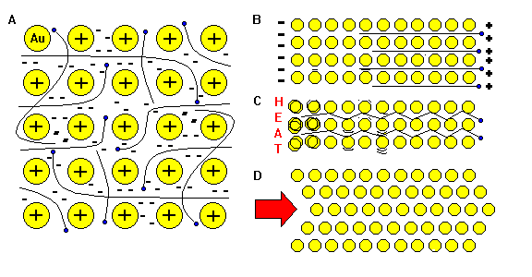
“A” shows the sea of valance electrons freely flowing among the metal cations left behind.

“B” shows the metal conducting electricity as electrons are put into one end of the piece of metal allowing some of the sea of valance electrons to flow out of the other end.

“C” shows how heat can be conducted through a piece of metal by both the sea of valance electrons and the vibrating metal cations.

“D” shows why a metal can be deformed (malleable and ductile) as the sea of electrons allows the metal cations to slip past one another.

accessed at: http://www.uwgb.edu/dutchs/EarthSC202Notes/minerals.htm

01. Name some metals found in or around your home, car, purse, or pocket.

Alloys are mixtures of two or more metals, or of metallic elements with nonmetallic elements. They often have physical properties that are very different from those of the pure metals. Gold, for example, is very soft in pure form (24-karat), which is why for jewelry, alloys of 18-karat or lower are preferred.

02. Name some alloys found in or around your home, car, purse, or pocket.

Match up the following four properties of metals and the reason for each of them.

03. High melting and boiling points |  | A) The bonds in metals don’t break easily
04. Ductile and malleable |  | B) Because the electrons are free to move, the atoms can slide over each other
05. Good conductor of heat and electricity |  | C) The bonds in metals are very strong
06. High tensile strength |  | D) The delocalized electrons are able to move freely throughout the metal

07. Use the key words to label your diagram:
Sea of delocalized electrons

Positively charged metal ions

Lattice

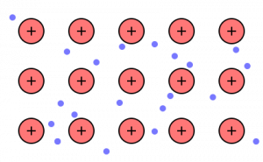
accessed at: http://blogs.scientificamerican.com/lab-rat/2012/03/21/metallic-bonding/

08. Use the “Sea of Electrons” model of metals to explain why electricity flows though copper wire so easily, but not through the insulation.
09. Use the “Sea of Electrons” model of metals to explain why heat flows through the stainless steel shank of the metal spoon you use to stir a pot of soup, but not through the plastic handle of the spoon.
10. Use the “Sea of Electrons” model of metals to explain why you can hammer nuggets of gold into flat sheets, but when you try that with rock salt, the crystals just shatter into smaller and smaller pieces.
11. Use the “Sea of Electrons” model of metals to explain why a tarnished silver spoon looks dull but a brand-new silver spoon looks shiny.
12. Use the “Sea of Electrons” model of metals to explain why wire rope is stronger than hemp rope.
13. Use the “Sea of Electrons” model of metals to explain why, when you are making caramel, the sugar melts, but the metal pan does not.

