Introduction to Electron Configurations
CSCOPE Unit 04 Lesson 01 Day 2

Vocabulary

Electrons |  | negatively charged subatomic particles with a mass of 1/1837 amu; found around the nucleus of an atom
Protons |  | positively charged subatomic particles a mass of 1 amu; found in the nucleus of an atom
Neutrons |  | subatomic particles with no charge and a mass of 1 amu; found in the nucleus of the atom
Valence electrons |  | electrons in the highest occupied shell (or level) of an atom
Energy levels |  | regions around the nucleus of an atom where an electron is likely to be moving

Today you will be arranging a set of cards representing the first twenty elements.

Each student will need to cut out a set of cards from pages 3 and 4 in this packet. Once you have cut them out, arrange them on your desk in four rows in a logical arrangement.

Get your teacher’s approval of your arrangement, then glue the first column and the last column into your notebook

01. What do the n’s on the cards represent?
02. What do the p’s on the cards represent?
03. How are electrons represented?
04. What do the circles represent?

05. How do the energy levels relate to placement on the periodic table?
06. What is the relationship among the number of valence electrons in the elements in each column of your arrangement?

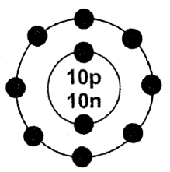 | 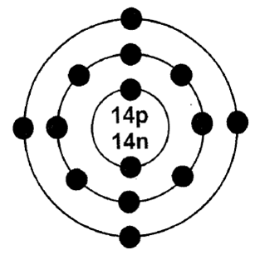 | 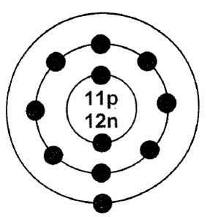 | 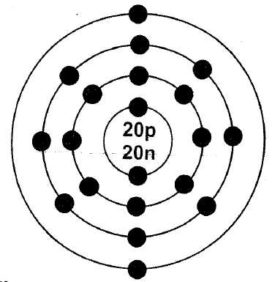
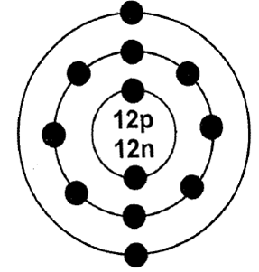 | 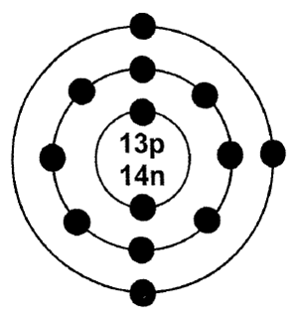 | 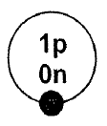 | 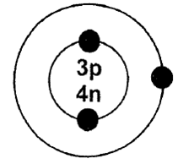
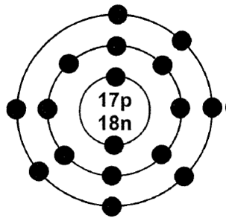 | 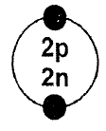 | 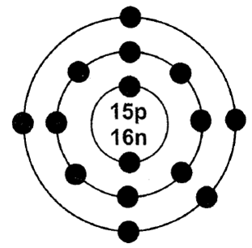 | 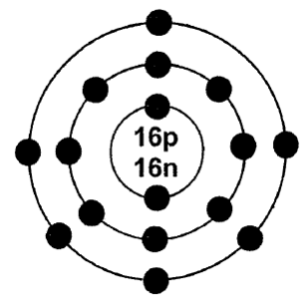

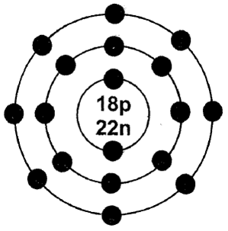 | 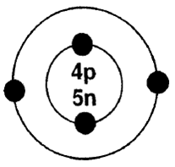 | 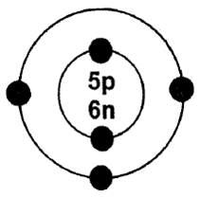 | 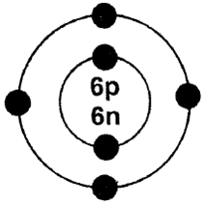
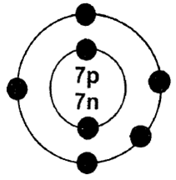 | 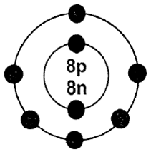 | 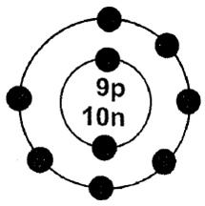 | 