Household Substances Lab
CSCOPE Unit 05 Lesson 01 Day 7

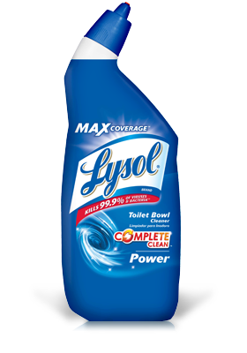 | Lysol Toilet Bowl cleaner contains hydrochloric acid. Write the formula for hydrochloric acid.
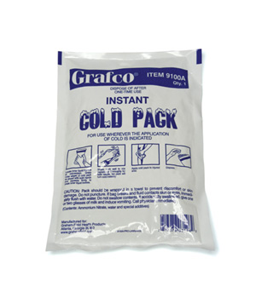 | Instant Cold Packs contain NH₄Cl. Give the name for NH₄Cl.
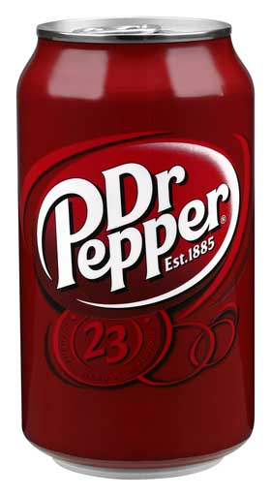 | Dr. Pepper contains carbonic acid. Write the formula for carbonic acid.
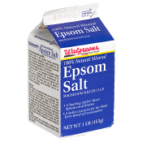 | Walgreen’s Epsom salts contains MgSO₄. Give the name for MgSO₄.
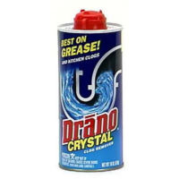 | Among other ingredients, the crystal form of Drano Crystal contains sodium nitrate. Write the formula for sodium nitrate.
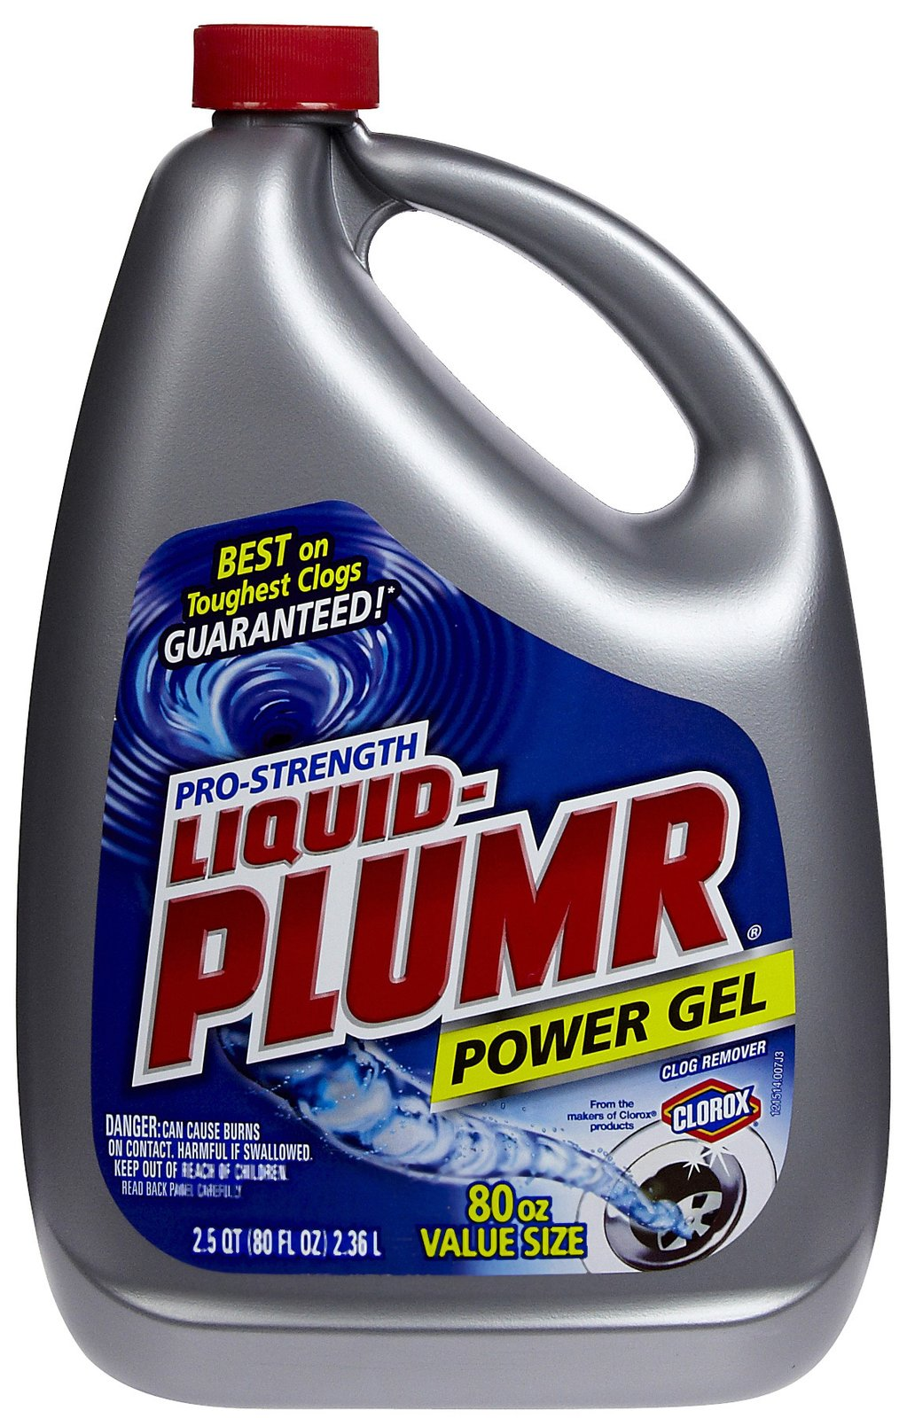 | Liquid-Plumr contains NaOH. Give the name for NaOH.
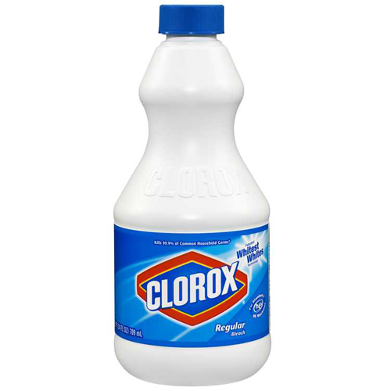 | Clorox bleach contains NaOCl. Give the name for NaClO.

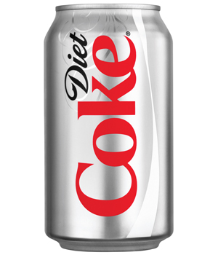 | One of the ingredients in Diet Coke is H₃PO₄. Give the name for H₃PO₄.
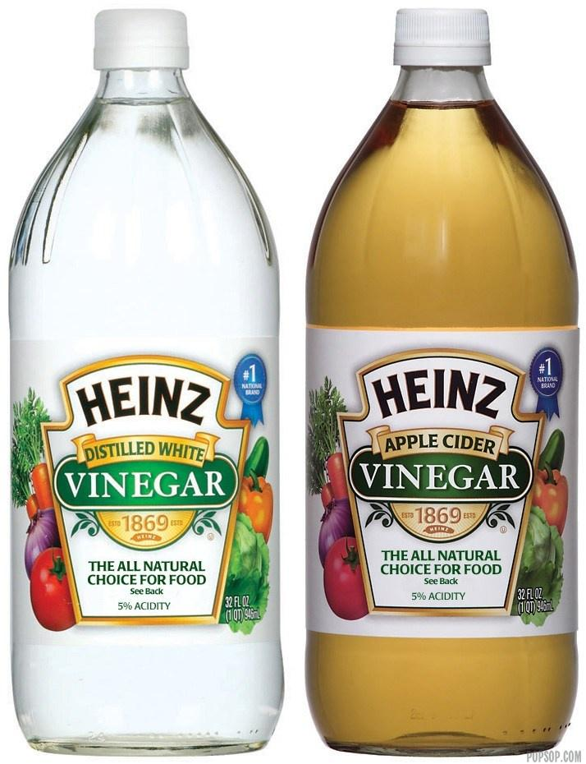 | Heinz vinegar contains acetic acid. Write the formula for acetic acid.
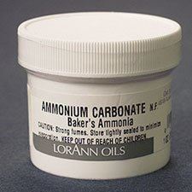 | Baker’s ammonia contains ammonium carbonate. Write the formula for ammonium carbonate.
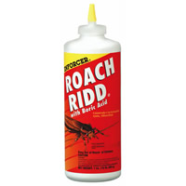 | Roach Ridd pesticide contains boric acid. Write the formula for boric acid. Hint: borate is BO₃^{3–}.
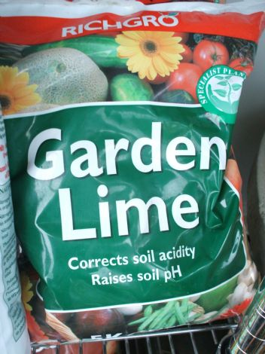 | Garden Lime contains calcium hydroxide. Write the formula for calcium hydroxide.
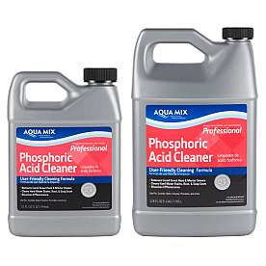 | Aqua Mix Phosphoric Acid Cleaner contains phosphoric acid. Write the formula for phosphoric acid.
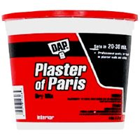 | Plaster of Paris contains calcium sulfate. Write the formula for calcium sulfate.

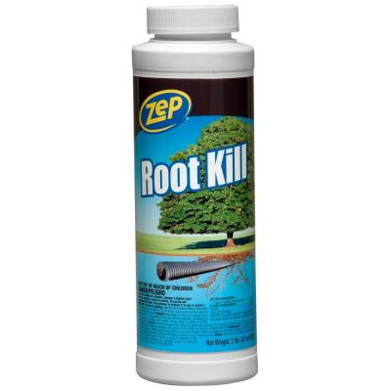 | Zep Root Kill contains CuSO₄. Give the name for CuSO₄.
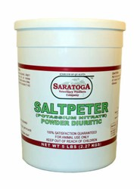 | Saratoga saltpeter contains potassium nitrate. Write the formula for potassium nitrate.
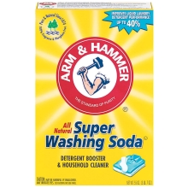 | Arm and Hammer Super Washing Soda contains Na₂CO₃. Give the name for Na₂CO₃.
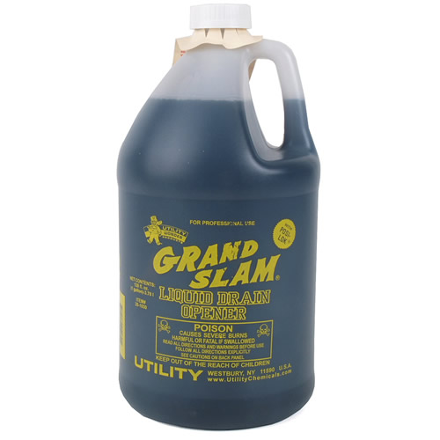 | Grand Slam Drain Opener contains H₂SO₄. Give the name for H₂SO₄.
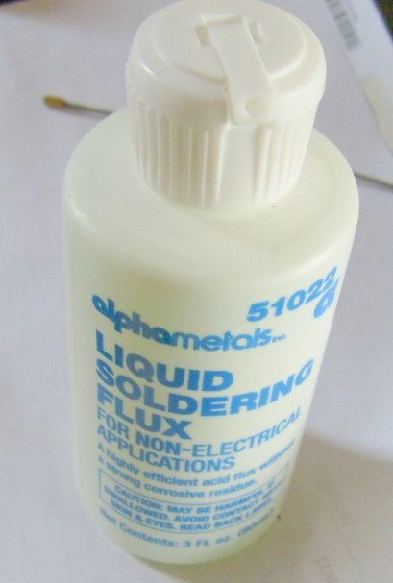 | Alphametals Liquid Soldering Flux contains ZnCl₂. Give the name for ZnCl₂.
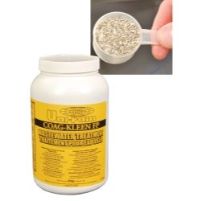 | Coag-Kleen Flocculant Powder for Waterborne Paint contains aluminum sulfate. Write the formula for aluminum sulfate.
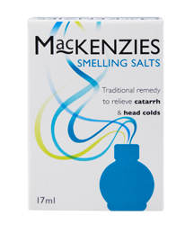 | MacKenzies Smelling Salts contains (NH₄)₂CO₃. Give the name for (NH₄)₂CO₃.

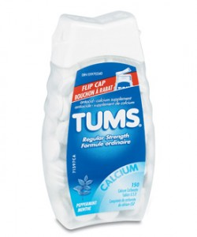 | Tums antacid contains CaCO₃. Give the name for CaCO₃.
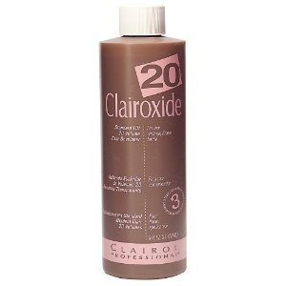 | Clairol Clairoxide contains dihydrogen dioxide. Write the formula for dihydrogen dioxide.
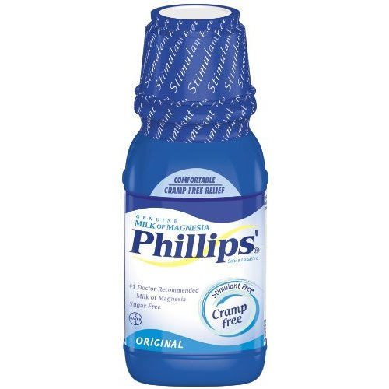 | Phillips Milk of Magnesia contains Mg(OH)₂. Give the name for Mg(OH)₂.
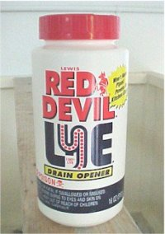 | Red Devil Lye contains potassium hydroxide. Write the formula for potassium hydroxide.
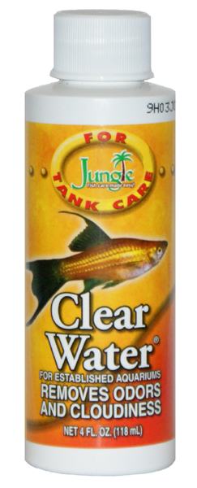 | Clearwater contains potassium permanganate. Write the formula for potassium permanganate.
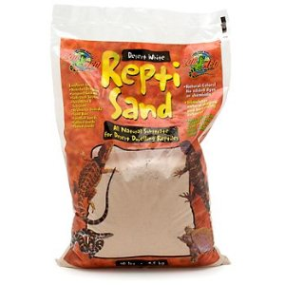 | ReptiSand contains SiO₂. Give the name for SiO₂.
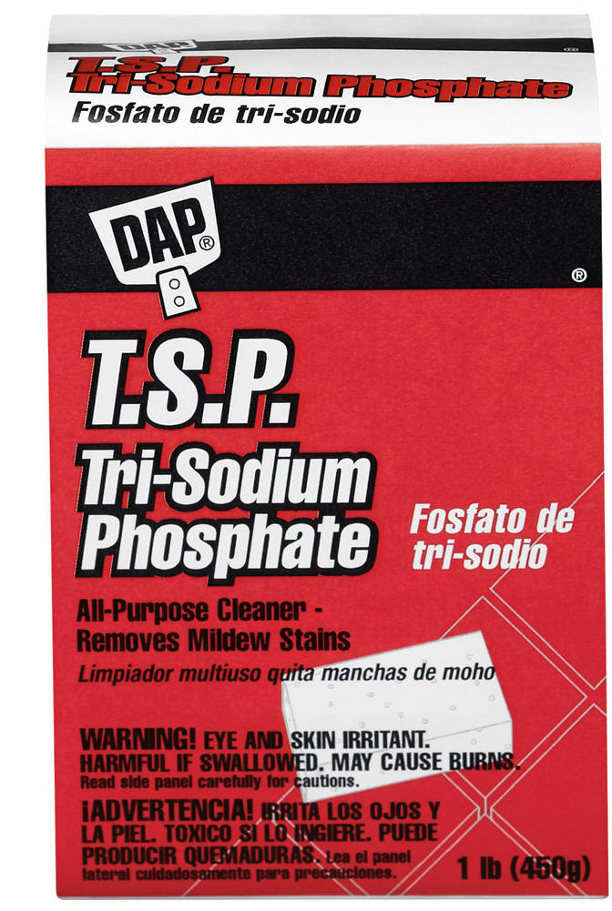 | Dap T.S.P. contains sodium phosphate. Write the formula for sodium phosphate.

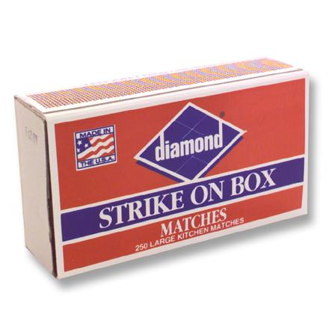 | Diamond “Strike on Box” matches contain potassium chlorate. Write the formula for potassium chlorate.
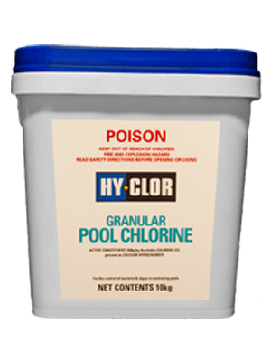 | Hy-Clor Pool Chlorine contains calcium hypochlorite. Write the formula for calcium hypochlorite.
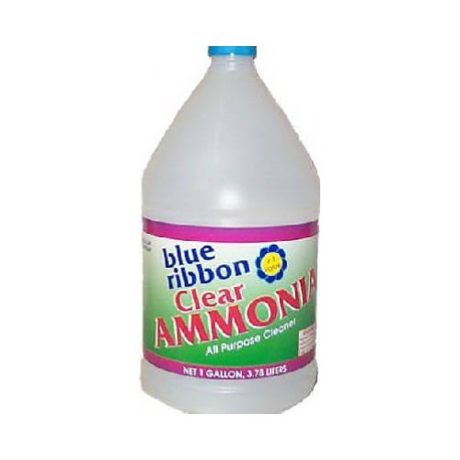 | Blue Ribbon Clear Ammonia contains NH₄OH. Give the name for NH₄OH.

