Scientific Measurement
CSCOPE Unit 06 Lesson 01 Day 1

Vocabulary

Accuracy |  | how close a measurement is to the true value
Accurate |  | a measurement is accurate if it has a value less than 0.5% for percent error
Analog device |  | a device that measures or represents data along a continuous scale, such as the hands of a clock, a ruler, a graduated cylinder, etc.
Calibration |  | involves checking an instrument against a standard
Digital device |  | reports data as a set of digits
Limits of precision |  | describes how repeatable a set of measurements are, is the first place to the right of the certain digits, which for analog devices is the first digit estimated between the marks, and for a digital device is the digit farthest to the right on the display
Precise |  | a set of measurements is precise if they differ by no more than the value of the last place
Precision |  | how close a set of measurements are to each other
Qualitative |  | based on descriptions
Quantitative |  | based on amounts

Qualitative and quantitative measurements
Qualitative measurements give results in descriptive, non-numerical form and use adjectives and adverbs. Quantitative measurements give results in a definite form and use numbers and units.

01. Identify the following measurement as qualitative or quantitative:
3,200 kg
02. Identify the following measurement as qualitative or quantitative:
very long
03. Identify the following measurement as qualitative or quantitative:
boiling hot

04. Identify the following measurement as qualitative or quantitative:
22.4 °C

Scientific Notation
In scientific notation a number is written as the product of two numbers a coefficient “M” and 10 raised to a exponent “10^{n} ”. “M” is a number greater than, or equal to 1, and less than 10. When written properly there will be only one digit to the left of the decimal. Scientific notation is used to express both very large and very small numbers. The sign of the exponent is positive if the decimal point has been shifted to the left, and it is negative if the decimal point has been shifted to the right. Numbers larger than 1 will have a positive exponent. Numbers smaller than 1 will have a negative exponent. Scientific notation is used with the mole. A mole is a shorthand way of referring to large numbers of objects (like 1 gross = 144). 1 mole of anything is 6.02 x 10²³ of that thing.

4 |  | 9 |  | 7 | 0 | 0 | ● | = 4.97 x 10⁴
 |  |  | ← | ← | ← | ←

0 |  | ● |  | 0 | 0 | 2 | 5 | 4 | = 2.54 x 10^{–3}
 |  |  |  | → | → | →

3 |  | 0 |  | 5 | 0 | = 3.05 x 10³
 |  |  | ← | ← | ←

● | 1 | 7 | 7 | 0 | = 1.770 x 10^{–1}
 | →

05. Given the following number:  1234  convert it to scientific notation. | a) Which direction, left or right, will be decimal need to be shifted to make “M” greater than, or equal to 1, and less than 10?  b) How many places does the decimal need to be shifted to make “M” greater than, or equal to 1, and less than 10?  c) Will the sign of the exponent “n” in 10^{n} be  positive or negative?  d) What is the correct answer?

06. Given the following number:  0.000098  convert it to scientific notation. | a) Which direction, left or right, will be decimal need to be shifted to make “M” greater than, or equal to 1, and less than 10?  b) How many places does the decimal need to be shifted to make “M” greater than, or equal to 1, and less than 10?  c) Will the sign of the exponent “n” in 10^{n} be  positive or negative?  d) What is the correct answer?

Precision and Accuracy
Precision
Precision is how close a set of measurements are to each other. Precision requires repeated measurements. It is improved by more careful use of the instrument. It is described in terms of the “limits of precision.” “Limits of precision” describes how repeatable a set of measurements are. The “limits of precision” is the first place to the right of the certain digits. Always read an instrument to the limits of precision. For digital devices, the limits of precision extend to the last digit to the right on the display. For analog devices, the limits of precision extend to the first digit estimated between the marks. “Precise” means that all of the measurements are very close to each other. A set of measurements is precise if they differ by no more than the value of the last place. You can test this by subtracting the smallest measurement from the largest measurement and determining the first place to the right where the measurements vary. That will be the limits of precision.

07. Compare these two graduated cylinders: | a) Which graduated cylinder is more precise?  b) How can you tell?  c) What are the limits of precision for graduated cylinder “B”?
  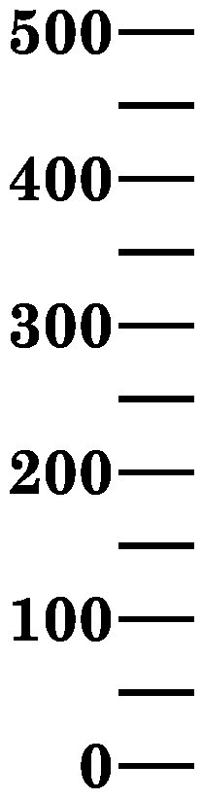 |  | 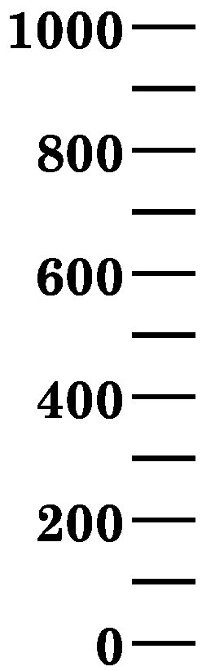
  A |  | B

08. Compare these two electronic balances: | a) Which balance is more precise?  b) How can you tell?  c) What are the limits of precision for balance “C”?  d) What are the limits of precision for balance “D”?
  1 | 0 | 0 | ● | 0 |  | 1 | 0 | 0 | ● | 0 | 0 | 0
  C |  |  |  |  |  | D

09. Are these measurements precise:  57.561, 57.575, 57.601
   |  |  | •
  − |  |  | •
   |  |  | •
10. Are these measurements precise:  29.998, 30.001, 29.997
   |  |  | •
  − |  |  | •
   |  |  | •

Accuracy
Accuracy is how close a measurement is to the true value. It requires a standard, which is something with a true or known value. It is improved by calibration, which involves checking an instrument against a standard. It is described in terms of error, usually percent error. “Accurate” means that a set of measurements is close to the actual or accepted value. Accuracy involves calculating an average for a set of measurements and comparing it to a standard using the percent error equation. A set of measurements is accurate if it has a value less than 0.5% for percent error. You can test this by using the percent error formula:

percent error | = | | actual value – experimental value | | x | 100%
percent error | = | actual value | x | 100%

11. Assume that the boiling point of water is 100.0 °C. What is the percent error if three students measure the temperature of a beaker of boiling water. One student gets 98.0°C. A second student gets 99.0°C. A third student gets 100.0°C | Calculate the average:  Use the percent error formula:

12. What two things do qualitative measurements use?
13. What two things do quantitative measurements use?
14. How can a quantitative measurement be distinguished from a qualitative measurement?
15. How many digits are there to the left of the decimal point in a number in properly written scientific notation?
16. What is the pattern between the direction the decimal was moved in the original number and the sign of the exponent in the scientific notation form?
17. What is the pattern of number of places the decimal was moved in the original number and the value (number part) of the exponent?
18. What is the relationship between the sign of the exponent in the scientific notation form and whether the original number was greater than one or less than one?
19. What does the term “limits of precision” describe?
20. For digital devices, what are the limits of precision?
21. For analog devices, what are the limits of precision?

22. What does “precise” mean?
23. What does “accurate” mean?
24. What is the test for precision?
25. What is the test for accuracy?
26. Identify each of these measurements as qualitative or quantitative: | a) extremely hot  b) 2.540 cm  c) freezing cold  d) 16 inches
27. Put the following into correct scientific notation: | a) 123  b) 0.23592  c) 4,909.6  d) 0.0006422

28. Refer to the pictures below. What are the limits of precision for each of the following graduated cylinders? | limits of precision for graduated cylinder “E”:  limits of precision for graduated cylinder “F”:  limits of precision for graduated cylinder “G”:

 |  | Graduated Cylinders
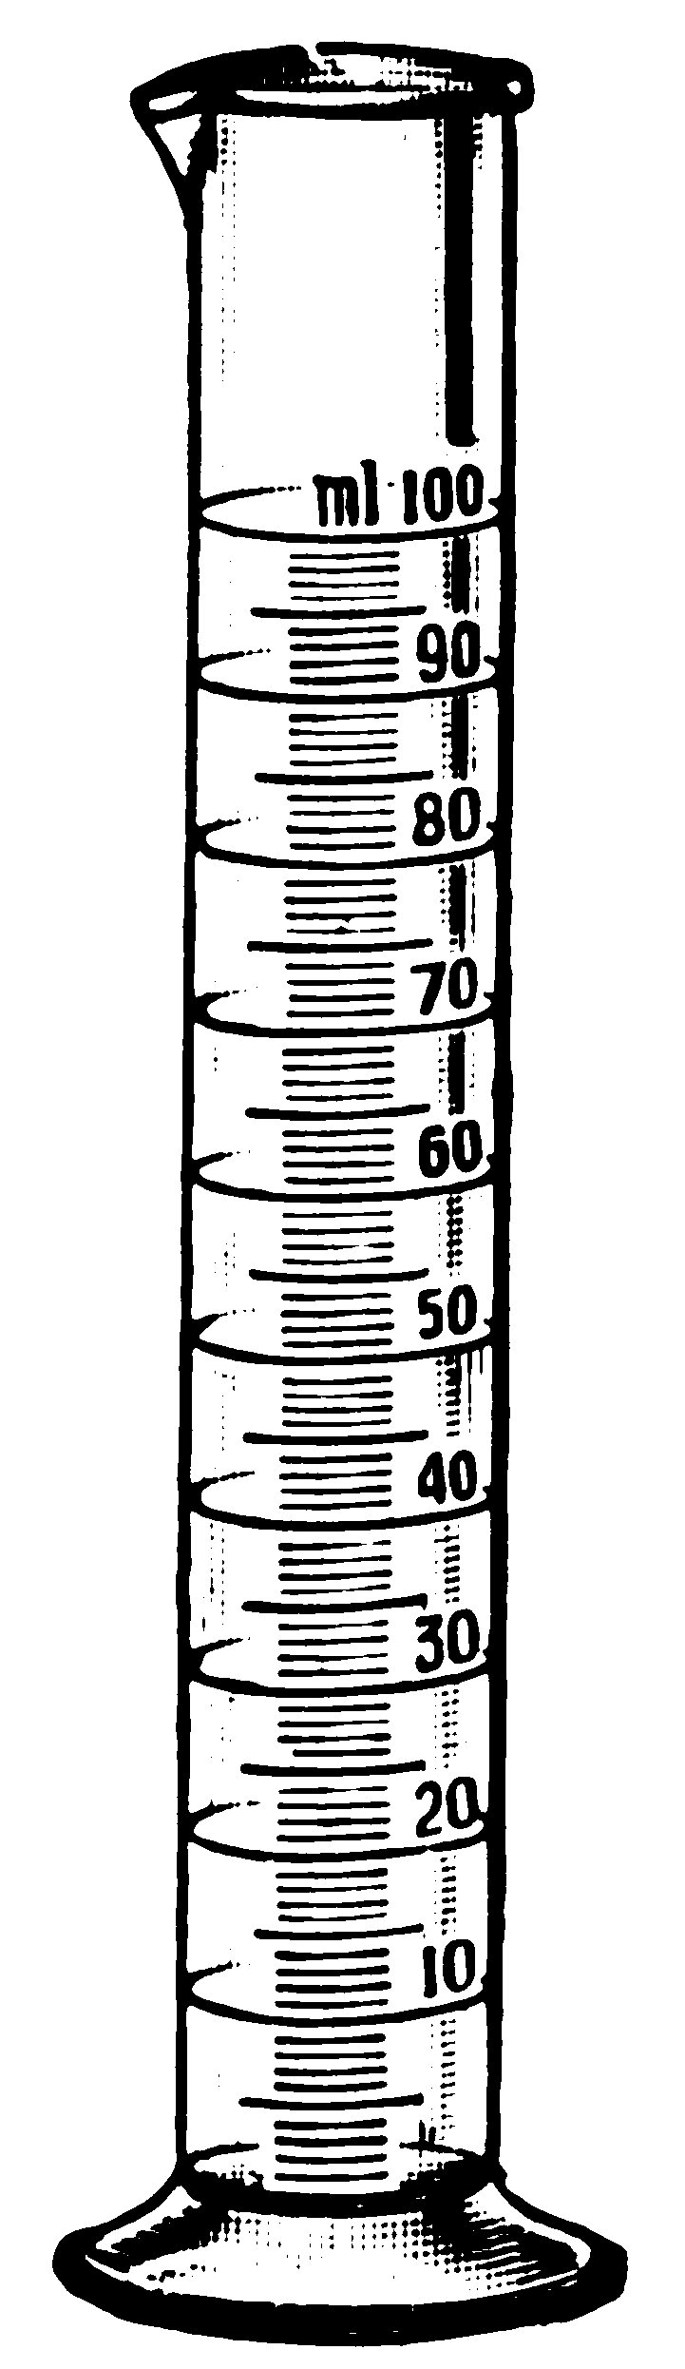 |  | 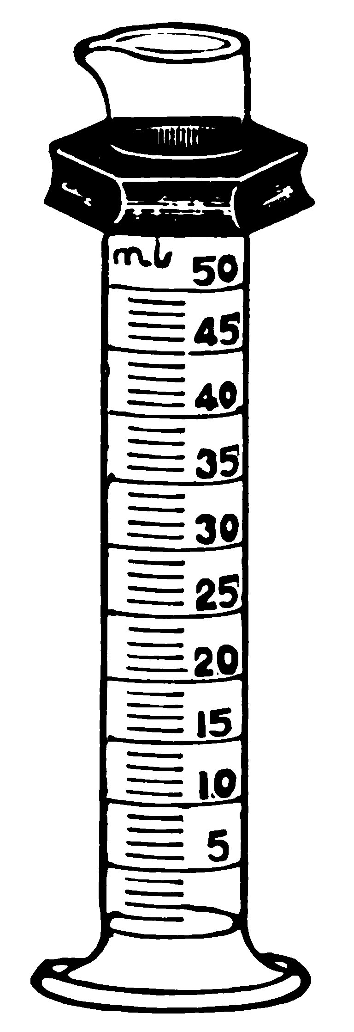 |  | 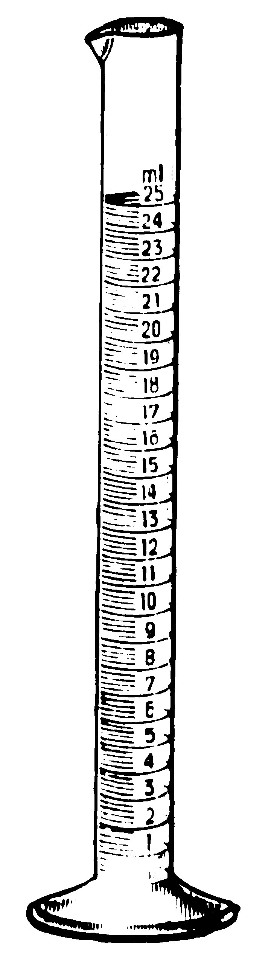
E |  | F |  | G

29. Does the following set of measurements meet the criteria for being precise? Explain.  504.85  503.63  506.74  505.56  503.97 | Show your work here:
30. Does the following set of measurements meet the criteria for being precise? Explain.  99.98  100.01  100.00  100.02  99.97 | Show your work here:
31. A student measured the density of water at 25 °C three times and got the following values:  1.247 g/mL  1.243 g/mL  1.245 g/mL.  The accepted value is 0.9970 g/mL. Are these measurements accurate? | Show your work here:

32. Four hunters are sighting-in their rifles before the start of deer season. Each hunter fires four shots.  Hunter 1 has a rifle that is precise but not accurate.  Hunter 2 has a rifle that is not precise but it is accurate.  Hunter 3 has a rifle that is neither precise nor accurate.  Hunter 4 has a rifle that is both precise and accurate. | Using a pencil, draw your four shots on the targets below.


IS precise  NOT accurate |  | NOT precise  IS accurate |  | NOT precise  NOT accurate |  | IS precise  IS accurate
1 |  | 2 |  | 3 |  | 4

