Solubility and Temperature and Pressure
CSCOPE Unit 10 Lesson 03 Day 3

Vocabulary

Solute |  | dissolved particles in a solution; what is dissolved
Solvent |  | the dissolving medium in a solution; what does the dissolving
Solubility |  | the amount of a substance that dissolves in a given quantity of solvent at specified conditions of temperature and pressure to produce a saturated solution
Dissolving |  | the process of a solute interacting with a solvent to  go into solution
Crystallization |  | the process of a dissolved solute coming out of solution and forming a crystalline solid
Soluble |  | a given solute will dissolve in a given solvent
Insoluble |  | A given solute will not dissolve in a given solvent
Miscible |  | fluids that will dissolve in each other in all proportions  (fluids are gases and liquids)
Immiscible |  | fluids that will not dissolve but will form separate layers
Unsaturated solution |  | a solution that contains less solute than a saturated solution at a given temperature and pressure; if a little bit more solute is added it will dissolve
Saturated solution |  | a solution containing the maximum amount of solute for a given amount of solvent at a constant temperature and pressure; if a little bit more solute is added it will lie on the bottom
Supersaturated solution |  | a solution that contains more solute than it can theoretically hold at a given temperature and pressure; if a little bit more solute is added it cause the excess to precipitate

Factors that affect solubility
Solids
Temperature
Temperature is the primary factor for solids.

The solubility of most solids increases as temperature increases, but for a few it is the reverse.

Pressure
Pressure changes have very little effect on the solubility of solids.

Gases
Temperature
The solubility of gases decreases as temperature increases.

Pressure
The solubility of gases decreases as pressure decreases.

Three terms relating to the amount of solute dissolved
Saturated solution
A solution containing the maximum amount of solute for a given amount of solvent at a constant temperature and pressure

If a little bit more solute is added it will lie on the bottom.

Unsaturated solution
A solution that contains less solute than a saturated solution at a given temperature and pressure

If a little bit more solute is added it will dissolve.

Supersaturated solution
A solution that contains more solute than it can theoretically hold at a given temperature and pressure

If a little bit more solute is added it cause the excess to precipitate.

Graphs like these represent the concentration of a solution in terms of mass of solute per 100 grams of water, usually. Any point ON the line for a solute represents the maximum amount of that solute that will dissolve at that temperature. This is a SATURATED solution. If the concentration for a specific solute at a specific temperature lies BELOW the line for that solute, then the solution would be UNSATURATED. If the concentration for a specific solute at a specific temperature lies ABOVE the line for that solute, then the solution would be SUPERSATURATED.

Graph 1
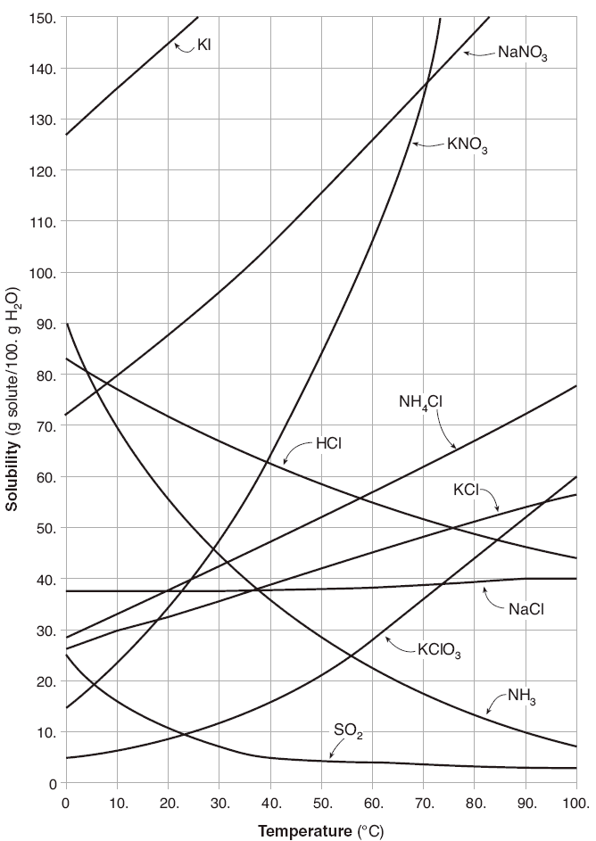
accessed March 18, 2013 at: http://castlelearning.com/review/reference/chem%20table%20g.htm

For Questions 1-10 use Graph 1 on page 3.

01. Which substance’s solubility changes the MOST from 0.°C to 100.°C?

02. Which substance’s solubility changes the LEAST from 0.°C to 100.°C?

03. What is the solubility of NaNO₃ at 20.°C?

04. What is the solubility of NH₄Cl at 40.°C?

05. What is the solubility of KNO₃ at 55°C?

06. What is the solubility of NH₄Cl at 72°C?

07. A mass of 80. g of NaNO₃ is dissolved in 100 g of water at 80.°C. As the solution is
cooled, at what temperature should solid first appear in the solution? Explain.

 | Concentration of Solution | What is the mass of solute that will dissolve at this temperature to form a saturated solution? | Is this solution saturated,  unsaturated or  supersaturated? | If the solution is unsaturated, then what additional mass of solute can dissolve in the solution? | If the solution is supersaturated, then what mass of solute should precipitate out of the solution?
08. | a solution at 60.°C that contains 110. g of NaNO₃ per 100 g H₂O
09. | a solution at 30.°C that contains 110. g of NaNO₃ per 100 g H₂O

10. A solution of KNO₃ is a saturated solution at 62°C. It is cooled to 45°C. How many
grams of KNO₃ should precipitate out of solution per 100 grams of water?
Graph 2
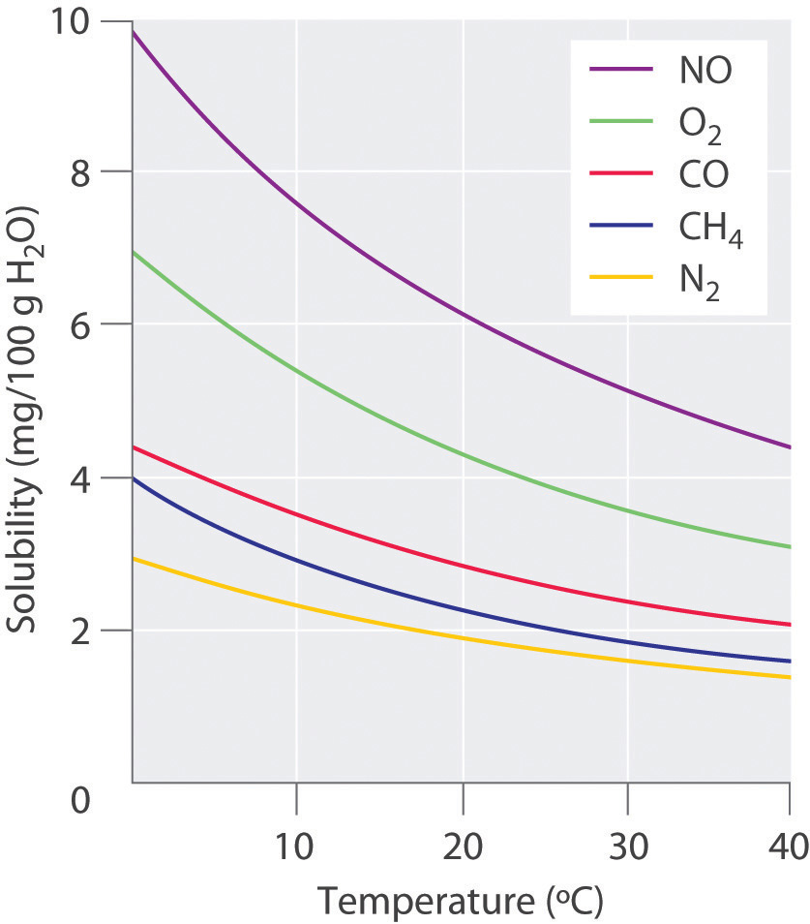
In order, from top to bottom, the curves are for NO, O₂, CO, CH₄, and N₂

accessed March 18, 2013 at: http://flatworldknowledge.lardbucket.org/books/general-chemistry-principles-patterns-and-applications-v1.0m/section_17_04.html

For Questions 11-13 use Graph 2 on page 5.

 | Concentration of Solution | What is the mass of solute that will dissolve at this temperature to form a saturated solution? | Is this solution saturated,  unsaturated or  supersaturated? | If the solution is unsaturated, then what additional mass of solute can dissolve in the solution? | If the solution is supersaturated, then what mass of solute should come out of the solution?
11. | a solution at 10.°C that contains 2.0 mg of N₂ per 100 g H₂O
12. | a solution at 30.°C that contains 2.0 mg of N₂ per 100 g H₂O

13. A solution of O₂ is a saturated solution at 10.°C. It is warmed to 30.°C. How many
milligrams of O₂ should come out of solution per 100 grams of water?

Graph 3
For Questions 14-16 use Graph 3 on page 7.

 | Concentration of Solution | What is the mass of solute that will dissolve at this temperature to form a saturated solution? | Is this solution saturated,  unsaturated or  supersaturated? | If the solution is unsaturated, then what additional mass of solute can dissolve in the solution? | If the solution is supersaturated, then what mass of solute should come out of the solution?
14. | a solution at 1.5 atm that contains 35 mg of CO₂ per 100 g H₂O
15. | a solution at 3.0 atm that contains 35 mg of CO₂ per 100 g H₂O

16. A solution of CO₂ is a saturated solution at 3.75 atm (the pressure in a Coke can
at 75°F. The pressure is reduced to 1.0 atm (room pressure) when the Coke can
is opened. How many milligrams of CO₂ should come out of solution per 100 grams
of water?

17. Power plants have to make sure that the cooling water that they discharge into
rivers or lakes is not too warm otherwise the fish will “drown.” Use what you know
about the solubilities of gases to explain this.

18. A can of soda starts to fizz when it is opened. Use what you know about the
solubilities of gases to explain this.

